Establishing an ADA grievance procedure

Who must establish an ADA grievance procedure?
Public entities with 50 or more employees (either full-time or part-time) must publish an ADA grievance procedure to resolve complaints alleging a violation of the ADA. Grievance procedures describe a system to address complaints related to accessibility and public facilities, services, programs, and activities.

What information should be included in an ADA grievance procedure?
A grievance procedure establishes a process for resolving complaints of disability discrimination in a timely and fair manner. Title II regulations do not include the specific points required to be included in a grievance procedure, however the Department of Justice provides a model grievance procedure.
According to the ADA Best Practices Tool Kit for State and Local Governments, an effective ADA grievance procedure includes:
- A description of how and where a complaint may be filed with the public entity
- If a written complaint is required, a statement notifying potential complainants that alternative means of filing will be available to people with disabilities who require such an alternative
- A description of the time frame and process to be followed by the complainant and the government entity
- Information on how to appeal an adverse decision
- A statement of how long complaint files will be retained
The following ADA grievance procedure flowchart provides recommended processes and time frames from the time a grievance is submitted to the municipality to final resolution of the grievance.

Grievance procedure flowchart
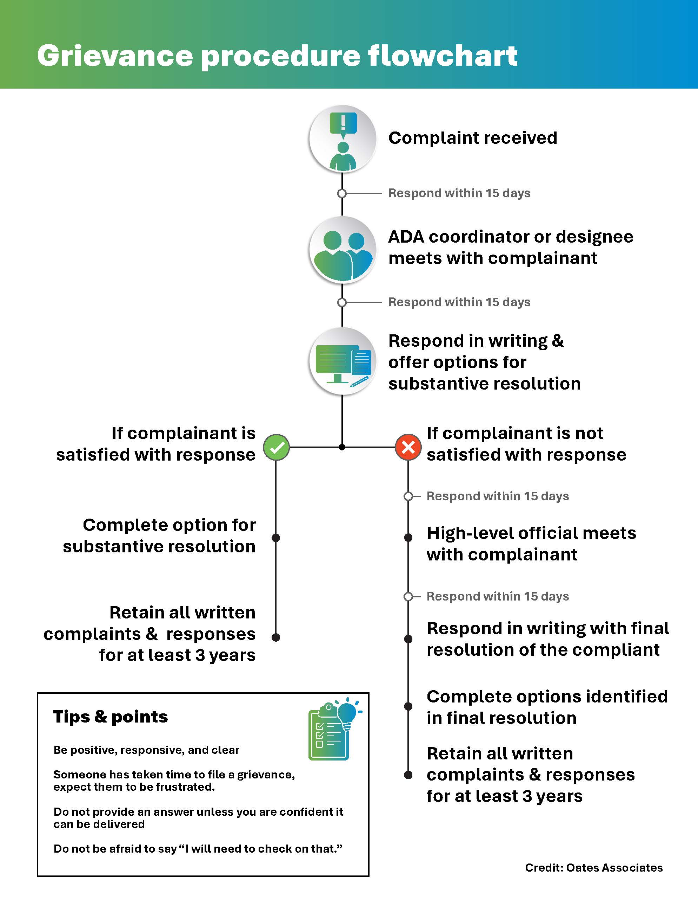
PDF Grievance procedure flowchart
Word (text only) Grievance procedure flowchart

